Department of Computer Science and Engineering (Data Science)

S.Y.B.Tech. Sem: IV
Subject: Computational Methods and Pricing Models Laboratory
Experiment 0
Name: Smayan Kulkarni SAP ID: 60009230142
Date: | Experiment Title: Time Value of Money Calculations
Aim | To compute and analyse various time value of money concepts including compound interest, present value, annuities, and perpetuities.
Software | Python on Google Colab, Calculator and Microsoft Excel
Theory | The time value of money (TVM) is a fundamental concept in finance that states a dollar today is worth more than a dollar in the future due to its earning potential. This experiment covers:  - Compound Interest - Interest earned on both initial investment and accumulated interest.  - Present Value - The value of future money in today's terms.  - Annuities - A series of equal payments made at regular intervals.  - Perpetuities - A type of annuity that continues indefinitely.  Excel provides built-in financial functions to calculate the time value of money.  FV (Future Value) Function  The FV function calculates the future value of an investment based on periodic, constant payments and a fixed interest rate.  =FV(rate, nper, pmt, [pv], [type])  rate – Interest rate per period.  nper – Total number of periods.  pmt – Payment made each period (use 0 for a lump sum investment).  pv – Present value (initial investment).  type – 0 (end of the period) or 1 (beginning of the period).  PV (Present Value) Function  The PV function calculates the present value of a future sum of money or an annuity.  =PV(rate, nper, pmt, [fv], [type])  rate – Interest rate per period.  nper – Total number of periods.  pmt – Payment made each period (use 0 if not applicable).  fv – Future value of the investment.  type – 0 (end of period) or 1 (beginning of period).  FV for Annuities  For annuities where you deposit $2,000 annually at 8% interest for 10 years, the FV function is:  =FV(8%, 10, -2000, 0, 0)  If payments are made at the beginning of the year (annuity due), use 1 instead of 0:  PV for Perpetuity  Perpetuities continue indefinitely, so we use the formula:  PV=P/r  =PV(6%, 9999, -4000, 0, 0)  (Using 9999 as nper simulates an infinite period.)
Implementation | Task 1: Future Value using Compound Interest  1. Consider an investment of $5,000 at an annual interest rate of 6%, compounded quarterly. Consider t as 1 year.  2. Manually calculate the future value using the compound interest formula:  FV = P × (1 + r/n)^(n × t)  3. Verify the result using Excel’s FV function.  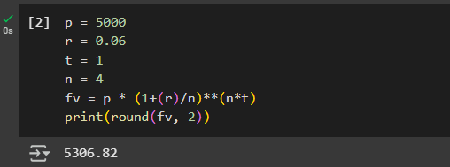  Task 2: Present Value of an Investment  1. You are offered an investment that will pay $10,000 after 8 years, with a required return of 7% per annum.  2. Compute the present value manually using the formula:  PV = FV / (1 + r)^t  3. Confirm the result using Excel’s PV function.  4. Explain whether the investment is worth accepting based on the computed present value.  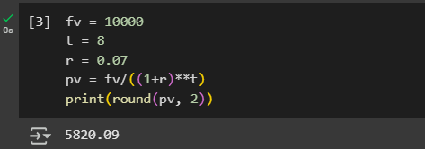  Task 3: Future Value of an Annuity  1. You plan to save for retirement by investing $2,000 at the end of each year in an account earning 8% annual interest, compounded annually. Consider t as 25.  2. Compute the future value of this annuity using the formula:  FV = P × [(1 + r)^t - 1] / r  3. Verify the result using Excel’s FV function.  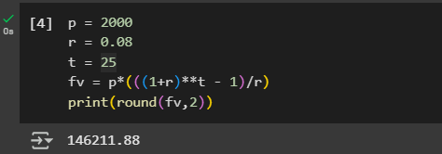  Task 4: Present Value of a Perpetuity  1. You are offered an investment that will pay $4,000 per year forever, starting one year from today.  2. If the required rate of return is 6% per annum, determine the present value using the formula:  PV = P / r  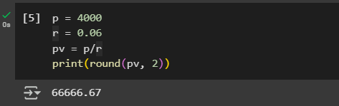  Task 5: Future Value of an Annuity Due  1. You decide to invest $3,000 at the beginning of each year in an account that earns 5% annual interest, compounded annually. consider t as 5 years  2. Compute the future value using the formula for annuity due:  FV_due = P × [(1 + r)^t - 1] / r × (1 + r)  3. Compare with the regular annuity calculation and analyze the benefits of annuity due.  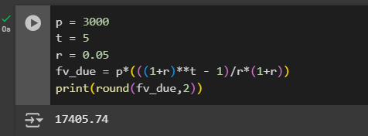
Conclusion | The experiment explored the Time Value of Money (TVM) concepts, including compound interest, present value, annuities, and perpetuities. Using Python, Excel, and manual calculations, various financial scenarios were analyzed. Key findings included the impact of compounding on future value, the role of discounting in investment decisions, and the benefits of annuities and perpetuities. Additionally, the comparison between regular annuities and annuities due highlighted how payment timing affects future value. These calculations reinforced the importance of TVM in financial decision-making.
Colab Link | https://colab.research.google.com/github/SmayanKulkarni/AI-and-ML-Course/blob/master/D100%20CMPM/exp-0.ipynb

